SHRI VAISHNAV VIDHYAPEETH
VISHWAVIDHYALAY
DEPARTMENT OF COMPUTER SCIENCE


SESSION-:2025-2026
Section: AI-D
Program : B.Tech CSE-AIML
SUBJECT : INTRODUCTION OF COMPUTER SCIENCE AND ENGINEERING
(BTCS101M)
SUBIMITTED TO: SUBMITED BY:
PROF. SACHIN CHIRGAIYa Shashank Jaiswal
Shri Vaishnav Vidyapeeth Vishwavidyalay
Shri Vaishnav Institute of Information Technology

INDEX

S.NO | Aim | Date of  Experiment | Date of  Submission | Sing/  Remark
1 | Design a Web Page, insert an image on to the web page such that image is of height 300 and width 300 pixels.
2 | Create a Web Page that hold a bulleted list of the name of your friends . Make sure that the bullets are in plane circle.
3 | Create a Frame which would hold the web page that was created earlier . The frame should be split row -wise into equal halves.
4 | Create a Web Page to display the marks you got in all subject’s of last semester using table.
5 | Create a Form having two boxes with labels as First Name and Last Name. The User should not be allowed to enter the names directly in the text boxes. The input has to be given in the prompt box and then entered values should be given in the textboxes.
6 | Create a Web Page that has a button in the centre of the page. Using mouse events change the Message in the status bar.

TITLE NO 1:. Design a Web Page, insert an image on to the web page such that image is of height 300 and width 300 pixels.
Procedure:
- Go to start ->all program – >accessories-> notepad
- Type the html code
- Include Error! Filename not specified.tag inside tag and set align attribute of img tag to middle
- Go to file->save->save the file with html extension
- Run the html code using browsres

CODE:-
<!DOCTYPE html>
<html>
<head>
<title>Image display</title>
<style>
Img {
height: 300px
width: 300px
}
</style>
</head>
<body>
<h1>My Favorite Image</h1>
<img src=“img nature.jpg” alt=“A Beautiful Nature” >
</body>
</html>
****OUTPUT****
A Beautiful Nature


TITLE NO 2: Create a Web Page that hold a bulleted list of the name of your friends . Make sure that the bullets are in plane circle.
Procedure:
- Open a Text EditorUse any text editor like Notepad (Windows), TextEdit (Mac), or a code editor like VS Code or Sublime Text.
- Start with Basic HTML Structure Begin by writing the basic structure of an HTML document:
- Add a Heading Inside the add a heading to label the list:
- Create a Bulleted List Use the tag for an unordered list and for each friend’s name:
- Save the FileSave the file with a .html extension, for example: friends.html.
- Open in a Browser Double-click the saved file or right-click and choose “Open with” → your preferred web browser.
- View Your Web Page You’ll see a heading and a bulleted list with plain circle bullets.
CODE
<!DOCTYPE html>
<html>
<head>
<title>My Friends</title>
<style>
Ul {
List-style-type: circle; /*Plain circle bullets*/
font-family: Arial, sans-serif;
font-size: 12px;
}
</style>
</head>
<body>
<h1>My Friends</h1>
<u1>
<li>PRATHA</li>
<li>PRERNA</li>
<li>ISHA</li>
<li>JAGRITI</li>
</body>
</html>

OUTPUT
My Friends
- PRATHA
- PRERNA
- ISHH
- JAGRITI

TITLE NO 3: Create a Frame which would hold the web page that was created earlier . The frame should be split row -wise into equal halves.
Procedure:
- Open your HTML editor,Use any text editor like Notepad, VS Code, or an online HTML editor.
- Create a new HTML file,Save it as something like framepage.html.
- Use the tag Replace the tag with to define the layout.
- Set up row-wise split,Use rows="50%,50%" to divide the screen into two equal horizontal sections.
- Insert tags Each loads a separate HTML file. Use the src attribute to point to your existing web pages.
CODE
<!DOCTYPE html>
<html>
<head>
<title>Row-wise Split Frame</title>
</head>
<frameset rows="50%,50%">
<frame src="top.html" name="topFrame">
<frame src="bottom.html" name="bottomFrame">
</frameset>
</html>

OUTPUT
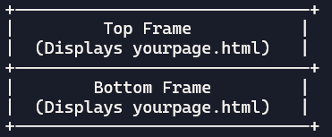
TITLE NO 4: Create a Web Page to display the marks you got in all subject’s of last semester using table.
Procedure:
- Open a Text Editor use any code editor like Notepad, VS Code, Sublime Text, or even an online editor like CodePen.
- Start with Basic HTML Structure Begin with the declaration and set up the , , and tags.
- Add a Title and Styling Inside the , use the - <head>, use the <title> tag to name your page. Add a <style> block to define how your table and page should look (colors, fonts, borders, etc.).Save the file with a html extension, like marks.html create a heading
- Inside the<body> , add a heading<h1> using to label your page (e.g., “My Last Semester Marks”).
- Build the Table Use the <table> tag. Add a header row with<th> for column titles like Marks Obtained, and Maximum Marks. Add rows with <tr>and cells with<td> for each subject and its marks.
- Save the File save the file with a .html extension, like marks.html
- Open in Browser double-click the file or right-click and choose “Open with” → your browser.
Codr:-
<!DOCTYPE html>
<html>
<head>
<title>Last Semester Marks</title>
<style>
body {
font-family: Arial, sans-serif;
background-color: #f4f4f4;
padding: 20px;
}
h1 {
text-align: center;
color: #333;
}
table {
margin: 0 auto;
border-collapse: collapse;
width: 60%;
background-color: #fff;
}
th, td {
border: 1px solid #ccc;
padding: 12px;
text-align: center;
}
th {
background-color: #e0e0e0;
}
</style>
</head>
<body>
<h1>Marks Obtained - Last Semester</h1>
<table>
<tr>
<th>Subject</th>
<th>Marks</th>
</tr>
<tr>
<td>Mathematics</td>
<td>85</td>
</tr>
<tr>
<td>Physics</td>
<td>78</td>
</tr>
<tr>
<td>Chemistry</td>
<td>82</td>
</tr>
<tr>
<td>English</td>
<td>90</td>
</tr>
<tr>
<td>Computer Science</td>
<td>88</td>
</tr>
</table>
</body>
</html>
OUTPUT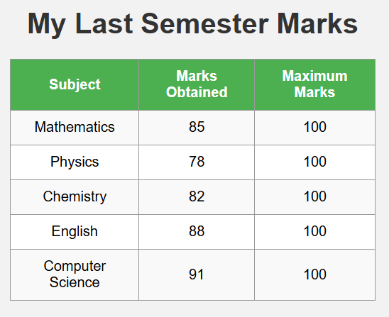Title no 5: Create a Form having two boxes with labels as First Name and Last Name. The User should not be allowed to enter the names directly in the text boxes. The input has to be given in the prompt box and then entered values should be given in the textboxes.
Procedure
- Create the HTML Structure open any text editor (e.g., Notepad, VS Code).Create a new file and save it as name_form.html. Add the basic HTML boilerplate:
- Add Form Elements Inside the, add two labeled text boxes and a button:
- Write JavaScript Logic below the form, add a <script> tag to handle input
- Style the Form (Optional) add a block inside to improve appearance:
- Run the Form open the saved name_form.html file in any web browser.Click the Enter Name button.Enter your first and last name in the prompt boxes.The values will appear in the read-only text fields.

CODE:-
<!DOCTYPE html>
<html>
<head>
<title>Prompt-Based Name Form</title>
<style>
body {
font-family: Arial, sans-serif;
padding: 30px;
background-color: #f0f0f0;
}
label {
display: block;
margin-top: 15px;
font-weight: bold;
}
input[type="text"] {
width: 300px;
padding: 8px;
margin-top: 5px;
background-color: #e0e0e0;
border: 1px solid #ccc;
}
button {
margin-top: 20px;
padding: 10px 20px;
font-size: 16px;
}
</style>
</head>
<body>
<h2>Enter Your Name</h2>
<form>
<label for="firstName">First Name:</label>
<input type="text" id="firstName" readonly>

<label for="lastName">Last Name:</label>
<input type="text" id="lastName" readonly>

<button type="button" onclick="getName()">Enter Name</button>
</form>

<script>
function getName() {
let first = prompt("Enter your First Name:");
let last = prompt("Enter your Last Name:");
if (first !== null) {
document.getElementById("firstName").value = first;
}
if (last !== null) {
document.getElementById("lastName").value = last;
}
}
</script>
</body>
</html>
OUTPUT:-
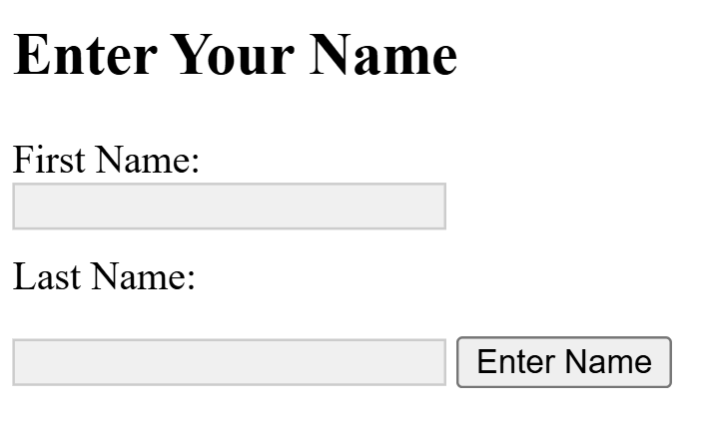

Title no 6:- Create a Web Page that has a button in the centre of the page. Using mouse events change the Message in the status bar.

Procedure:-
- Create the HTML Structure
- Start with a basic HTML5 template.
- Add a <>element inside the
- Center the Button Using CSS
- Use Flexbox to center the button both vertically and horizontally.
- Add Mouse Event Handlers
- Use inline JavaScript event attributes to update the status bar.
- Save and Run
- Save the file with a .html extension (e.g., status-button.html).
- Open it in a browser. Hover and click the button to see status bar updates.
Code:-
<!DOCTYPE html>
<html>
<head>
<title>Mouse Events Status Bar</title>
<style>
body {
display: flex;
justify-content: center;
align-items: center;
height: 100vh;
margin: 0;
}
button {
padding: 20px 40px;
font-size: 18px;
cursor: pointer;
}
</style>
</head>
<body>
<button
onmouseover="window.status='Mouse is over the button'"
onmouseout="window.status='Mouse left the button'"
onclick="window.status='Button clicked!'">
<p><a href="https://www.w3schools.com/html/default.asp">Hover or Click ME</a></p>
</button>
</body>
</html>
OUTPUT:-
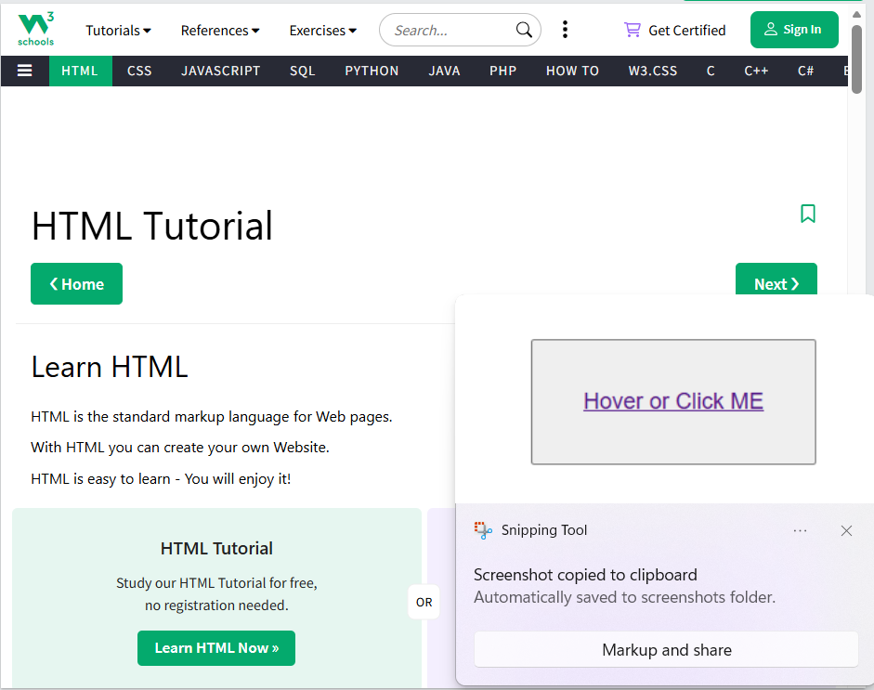
Title no 7: Design a Web page that accepts Username and Password. Opens a new window when the password corresponds to a particular value is set by the develop

Procedure:-
- Create the HTML Structure
- Use elements for username and password.
- Add a to trigger login validation.
- Add JavaScript for Validation
- Define a function checkLogin() that:
- Retrieves values from the input fields.
- Compares the password to a developer-defined value.
- Opens a new window if the password matches.
- Style the Page (Optional)
- Use CSS to center the form and improve appearance.
- Test the Page
- Open the HTML file in a browser.
- Enter a username and the correct password
- Confirm that a new window opens to the specified URL.
CODE:-
<!DOCTYPE html>
<html>
<head>
<title>Login Page</title>
<script>
function checkLogin() {
const username = document.getElementById("username").value;
const password = document.getElementById("password").value;
const developerPassword = "12345678"; // Developer-defined password
if (password === developerPassword) {
window.open("https://www.wikipedia.com", "_blank"); // Opens new window
} else {
alert("Incorrect password. Please try again.");
}
}
</script>
<style>
body {
font-family: Arial, sans-serif;
display: flex;
justify-content: center;
align-items: center;
height: 100vh;
margin: 0;
background-color: #f0f0f0;
}
.login-box {
background: white;
padding: 30px;
border-radius: 8px;
box-shadow: 0 0 10px rgba(0,0,0,0.1);
}
input {
width: 100%;
padding: 10px;
margin: 10px 0;
font-size: 16px;
}
button {
width: 100%;
padding: 10px;
font-size: 16px;
background-color: #007BFF;
color: white;
border: none;
border-radius: 4px;
cursor: pointer;
}
button:hover {
background-color: #0056b3;
}
</style>
</head>
<body>
<div class="login-box">
<h2>Login</h2>
<input type="text" id="username" placeholder="Enter Username" required>
<input type="password" id="password" placeholder="Enter Password" required>
<button onclick="checkLogin()">Login</button>
</div>
</body>
</html>

OUTPUT:-
